Grade: VIII CH – 17: Refraction and Dispersion of Prism
- The distance between the object and its image formed by a plane mirror appears to be 18 cm. What is the distance between mirror and the object?
Answer: 9 cm

- How is hypermetropia corrected?
Answer: It is corrected by using convex lens.

- How is myopia corrected?
Answer: It is corrected by using concave lens.
- What is yellow spot?
Answer: It is highly light sensitive spot for seeing things with highest clearness.
- Sathyan planned an activity to observe an object A through pipes as shown in the given figure, so that he could see objects which he could not directly see.
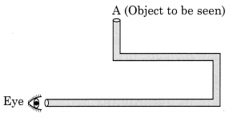
(a) How many mirrors should he use to see the object?
(b) Indicate the positions of the mirrors in the figure.
(c) What must be the angle with respect to the incident light at which he should place the mirrors?
(d) Indicate the direction of rays in the figure.
(e) If any of the mirrors is removed, will he be able to see the object?
Answer:
(a) Three
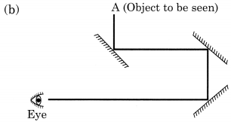
(c) 45°
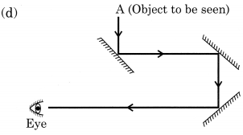
(e) No, he will not be able to see the object.

- While playing, something entered into Soumya’s eye. She immediately washed her eye with cold water. But as the irritation persisted, she immediately reported to her class teacher. Her class teacher took her to an eye doctor.
- What should be done if some foreign particles enter your eyes?
- Why is it not advised to rub your eyes when there is an eye irritation due to foreign particles?
- Do you think Soumya was right in her action?
- What value of Soumya is seen here?
Answer:
- We must do the following things:
  - Restrict eye movement
  - Shut the eyelid
  - Do not rub eyes
  - Try to clean it with splash of clear water
  - Contact eye doctor immediately.
- Foreign object may cause abrasions or scratches on our cornea or rubbing. It may also cause bleeding of cornea.
- Yes.
- She is intelligent, knowlegeable and aware of such kind of small accidents.
- Match the items given in column I suitably with those given in column II.
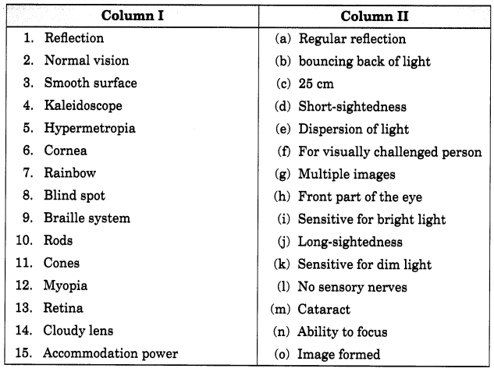
Answer:
1. (b)
2. (c)
3. (a)
4. (g)
5. (j)
6. (h)
7. (e)
8. (l)
9. (f)
0. (k)
11. (i)
12. (d)
13. (o)
14. (m)
15. (n)

